Innisfail & District Show Society Inc.

President: Mr. L.Zahra P.O. Box 1126
Secretary: Mrs. M. DeBrincat Innisfail Q. 4860
Telephone: Office: (07) 4061 3051
Email: innisfailshow@gmail.com

OUTSIDE SPACE CONTRACT - 2024 INNISFAIL SHOW

FOOD STALL HOLDERS TO SUPPLY COPY OF FOOD LICENCE

- ORGANISATION DETAILS

Name of Organisation/Trading Name: ………………………………………………………………………………….

Contact Person: …………………………………………………………ABN…………………………………………..

Postal Address:-…………………………………………………………………………………………………………...

……………………………………………………………………………………………Postcode………………………

Telephone (Business)………………………… (Mobile)……………………………. (Fax)…………………………

Email address...................................................................................................................................................

- SPACE REQUIREMENTS

I/we hereby apply for :
- FRONTAGE (m)………………… and Preferred Depth (m)…… ………….. space in the OUTSIDE position
AREA ………at ................per metre ( Actual Stall Dimensions)
2. and FRONTAGE (m)………………… and Preferred Depth (m)…… ………….. at ....$3.00............per square metre space for ancillary parking behind main stall (Area C & D) for the forthcoming Innisfail & District Show to be held on the 11th and 12th July, 2024. Size of area cannot be guaranteed. (Area C & D Stall Holders Only), Free Parking available in Itinerant Camping Ground. DO NOT WRITE “SAME AS LAST YEAR” ENTER MEASUREMENTS

Costs for OUTSIDE Space: SEE MAP FOR AREAS
- Allocated in 3 metre Sections, unless otherwise decided.
- AREA A - $3.00 per square metre (reserved for Machinery and large items ie. Boats, cars, bikes)
- AREA B $200 EACH SIDE (includes 4 Free Ticket Vouchers)
- Frontages less than 10 metres AREA C $50.00 per metre (includes 4 Free Ticket Vouchers)
- Frontages 10 metres or more AREA C $42.00 per metre (includes 4 Free Ticket Vouchers)
- Charities/fund raising groups (schools, sports assoc)/Govn services $27.00 per metre frontage (No further discount applies)
- Cassowary Coast Traders receive a 10% Local’s Discount for AREAS C
- Ticket Vouchers can be used only Once, but pass out stamps obtained for each person producing a voucher
- Additional Ticket Vouchers can be obtained from the Secretary’s Office at a cost of $6.00 each
- Space will not be allocated unless an application form as been submitted with deposit, Regardless of how many years you have been attending the Innisfail Show (We do not have telepathic powers).
- On approval of your application, a Tax Invoice will be forwarded to you for payment. Your site will
Not be guaranteed until full payment has been received.
**When measuring Vans, include the space taken by tow bars etc. and with tents, the space taken by tent ropes and pegs. The total space taken up by you will be measured and additional charges levied if necessary**
Explanation of the types of goods to be on display/sold on this stand: ........................................................................................................................................................................................................................................................................................................................................................................................
- In Fairness to All stall holders please ensure you have listed all items for sale
- The Innisfail & District Show Society Inc hold the right to ask items to be removed from sale.
- The Innisfail & District Show Society Inc reserves the right to reject any application in its sole discretion and its decision in this regard shall be final.
- The Final Placement of stalls is at the sole discretion of the Innisfail & District Show Society Inc. YOUR PREFERRED SITE IS NOT GUARANTEED.
- All exhibitors and itinerants must contact the Office before setting up stall.

- POWER – 240V POWER SUPPLIED, NO 3 PHASE POWER
(Please see Notice of Compliance page)

NO WE DO NOT REQUIRE POWER

YES WE REQUIRE 10 AMP POWER (SINGLE POINT) Extra@ $20.00 per point. (Depending on site allocation) Innisfail Show Society will advise the maximum points allowed.

YES OTHER, FOOD & DRINK VANS. Please advise how many points and amps required, cost will be worked out by Show Society

Please list Electrical items to be used and wattage

Item 1:_____________________________________ Wattage_______________________ Qnty_______________

Item 2:_____________________________________ Wattage_______________________ Qnty_______________

Item 3:_____________________________________ Wattage_______________________ Qnty_______________

If you require more space, please attach separate page

- PRIVACY ACT:- Please indicate your consent or non-consent , by placing a tick in the relevant box, to your contact details being passed on to customers. All other information will remain confidential.

Consent Non-Consent

- PUBLIC LIABILITY INSURANCE:
It is a requirement of the Innisfail & District Show Society Inc that all exhibitors have Public Liability Insurance. The indemnity level should be a minimum of $20million. In most cases, the liability policy used for your normal business will probably extend to the Innisfail Show for 2024, however, please confirm this with your Insurance Company.

Please complete the following details:

Insurer:……………………………………………………………….Policy No………………………………………………

Indemnity Level……………………………………………………..Current to………………………………………………

(Find a copy of *Current* Insurance Policy enclosed)

Bank Details for Direct Deposit: PLEASE NOTE NEW BANKING DETAILS

Account Name: Innisfail & District Show Society Inc.
Account Number: 64184012
BSB Number: 654-000
(Please include Invoice Number in Reference Section, or email remittance advice to the address above)

I agree to be bound by the Rules for Stall Holders as attached.
Stall Holders must supply a copy of their COVID Safe plan

Find attached $50.00 Deposit Payment by Direct Deposit (Bank Details as per Key Information for Stallholders) for Space for 2024 Show. I understand payment of a deposit does not Guarantee a Space.

…………………………………. (…………………………….) ……………………………..
Signature of Applicant Print Name Date

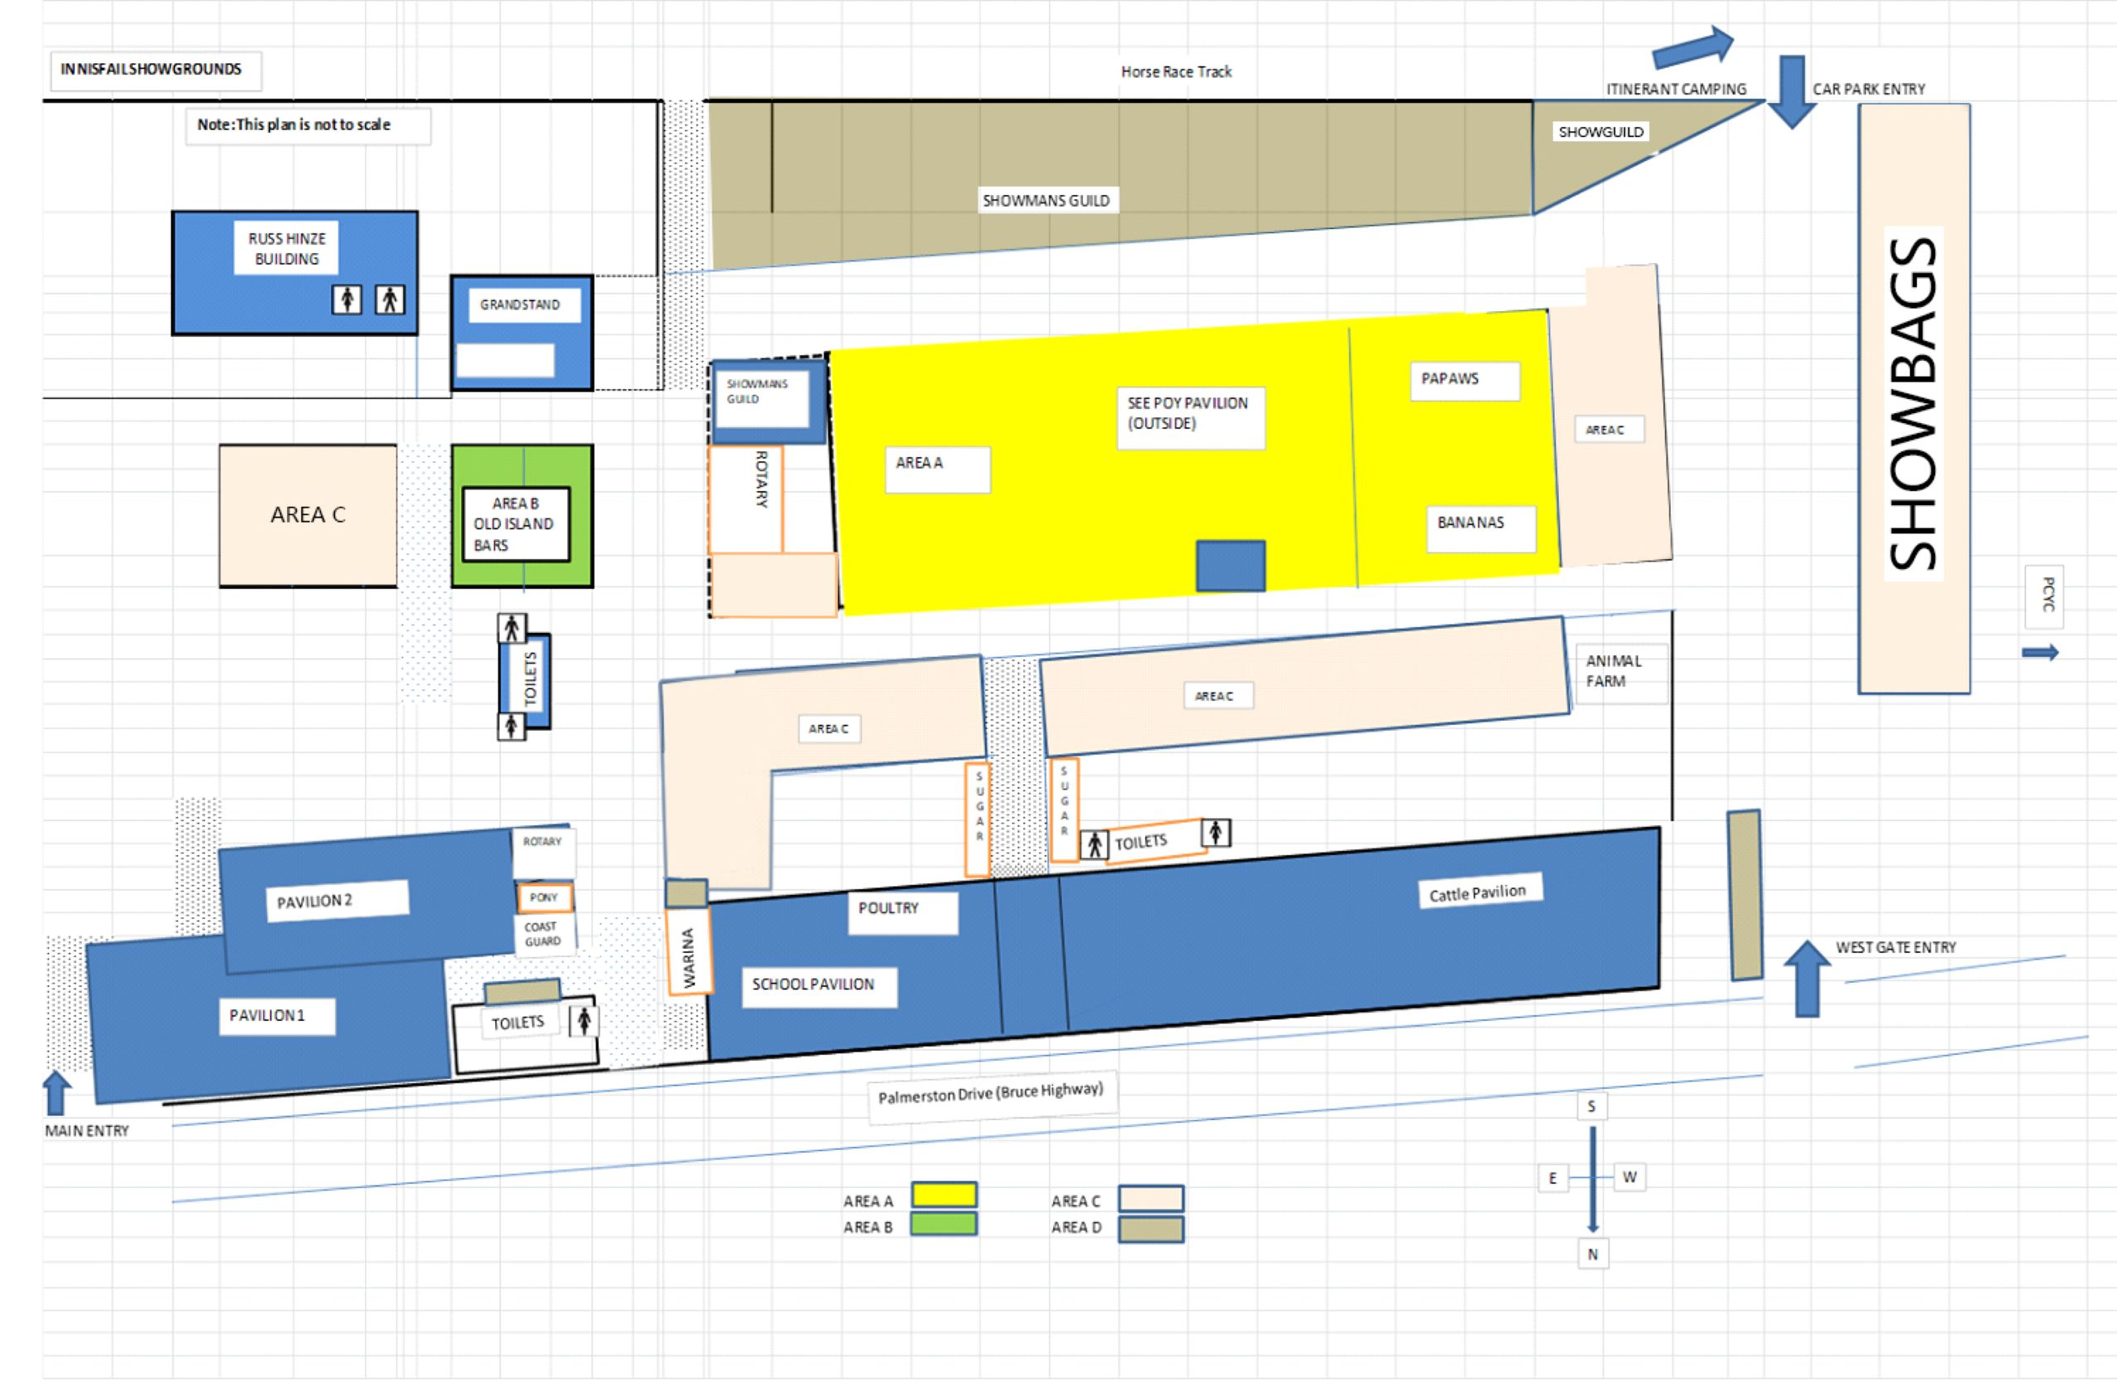

ELECTRICAL USEAGE FROM POINT OF SUPPLY

The Innisfail Show Society Inc., prefers that all Exhibitors, Operators of Show
Amusements, Show Stalls or commercial activities use Electrical Safety Switches to
be plugged in at all times at the ‘Point of Supply’.

When constructing amusements and displays IT IS COMPULSORY to use electrical
safety switches at the ‘Point of Supply’ and leads MUST BE TESTED AND TAGGED.
The ‘Point of Supply’ is the permanent location of power points (single )
or similar type of connection connected to the Innisfail Show Society Inc’s
electrical installations.
When exhibits, food outlets, displays and amusements are operational, everyone
MUST COMPLY with one of the following:

• Electrical Safety Switch at ‘Point of Supply’

OR

• Tagged and tested electrical leads

At all times electrical leads MUST NOT IMPEDE the flow of pedestrians and
vehicles. Leads will be checked at the Innisfail Show.
___________________________________________________________________
GAS CYLINDERS IN PUBLIC LOCATIONS:

WHERE A CYLINDER EXCEEDING 12 L CAPACITY IS PERMANENTLY INSTALLED
FOR PUBLIC USE IN ANY SPORTSGROUND, FAIRGROUND, PARK, PLAYGROUND,
CARAVAN PARK, OR SIMILAR PUBLICLY ACCESSIBLE LOCATION, the following
requirements shall apply:

(a) Either –
(i) the cylinder and any associated regulator shall be enclosed in a
lockable cage or cabinet ventilated top and bottom

OR
(ii) The cylinder valves and regulator shall be guarded by a covering metal
hood, and the cylinder shall be protected against accidental
dislodgement.

(b) The connecting piping shall be arranged so that it is not vulnerable to accidental impact or tampering

LIST OF BANNED ITEMS AT AGRICULTURAL SHOWS

✗ | Drug Related Goods (including | ✗ | Pressure Pack Fart Gas
 | Cocaine Kits, Bongs etc.) | ✗ | Silly String
✗ | Explicit and Hardcore T-Shirts | ✗ | Stink Bombs
✗ | Fake Cigarettes | ✗ | Bouncing Beans
✗ | Fireworks – Crackers | ✗ | Shang-hi/sling shots
✗ | Fuel type Fire Lighters (Zippo) | ✗ | Bomb Bags
✗ | Horns and Trumpets | ✗ | Fire Wallets
✗ | Knives (including Pen Knives) | ✗ | Water Bomb
✗ | Laser Pointers | ✗ | Explicit DVD's and Videos
✗ | Metal and wooden Martial Art | ✗ | Iridescent Hair Spray
 | Nunchakus
✗ | Playing Cards (nude or lurid)
✗ | Pressure Pack Snow

Toy Guns are acceptable, however the following are not:
✗ Ball Bearing Guns
✗ Eight Shot Caps
✗ Pellet Guns
✗ Pop Downs (Throw Downs)
✗ Potato Guns
✗ Replica Guns (bullet type)
✗ Roll Caps
✗ Strip Caps
✗ Water Pistols over 150mm (6”)
✗ Gel Blaster Guns

Samurai Swords, English Swords and Fencing Swords are to be sold in Sealed Packages by Licensed Traders ONLY.

This list complies with Queensland Chamber of Agricultural Societies agreed list of banned items.

Banned Items List v2 Feb 2021

Innisfail & District Show Society Inc.

President: Mr L.Zahra PO Box 1126
Manager: Mrs M.DeBrincat Innisfail Qld 4860
Telephone: (07) 4061 3051
Email: innisfailshow@gmail.com
RULES FOR STALL HOLDERS

(Failure to comply with the undermentioned Rules will result in Cancellation of Space)

- Deposit on space rent to be paid on or before 30th March 2024 otherwise your allocated space will be reallocated.
- Total rental charges must be paid at the Secretary’s Office by 5.00pm Friday, 24th May, 2024.
- Exhibitors must have their own Covid Safe Plans and Public Liability Insurance, Copies sent to the Innisfail & District Show Society prior to permission being given for space.
- Display stands must be completed by 9.00am Thursday 11th July, 2024. If the display is not completed, the Innisfail & District Show Society have the right to reallocate this space.
- Display stalls or fixtures must NOT be dismantled or goods or materials removed before 10.00p.m. on the last day of the show. All goods and materials are to be removed and stall completely vacated not later than 12 noon on Saturday, 13th July, 2024.
- The within described area to be used only and solely for the purpose specified herein. NO SUB-LETTING will be permitted without the written permission of the Secretary.
- Gambling, disposal of any article by the lot or chance, and sale of Art Union Tickets STRICTLY PROHIBITED.
- The Lessee (Spaceholder) must confirm his/her business to the purpose described herein. No selling, canvassing, hawking or distribution of printed or other matters will be permitted outside the area contracted for.
- The Lessee (Spaceholder) and/or employees to conduct themselves in an orderly and respectful manner while they are on the Show Grounds.
- The Secretary or Executive Committee Members of the Society shall have the power to enter upon the area described and remove any article, sign, picture or printed matter which in his/her opinion may be a cause of offence to the Public or to the Officials of the Society.
- The display of approved advertising signs of any description is restricted to the area occupied by the Spaceholder.
- Trade Vehicles, vehicles conveying supplies and vehicles owned by or used by the Spaceholders or Exhibitors are not permitted to remain in the Showgrounds after 9.00am Thursday and 8.30am Friday of Show days.
- Hawking by stall Holders during the Annual Show on the Showgrounds is PROHIBITED unless special permission is granted by the Committee of the Society.
- Under no circumstances shall a spaceholder excavate, dig or place pegs in his area without first obtaining authority from the Show Ground Committee.
- This Society undertakes to rent the space and buildings thereupon in their present conditions. All subsequent plumbing, carpentry and electrical requirements will be the responsibility of the Lessee (Spaceholder).
- P.A. Systems, Projectors, or any other sound units shall not be operated without permission in writing from this Society.
- It is agreed that this Society will not under any circumstances be held responsible for any loss of or any damage to the stock in trade etc, or any part thereof of any Spaceholder or Exhibitor from any cause whatsoever.
- All show stands and offices to have litter bins on the show stand which can be emptied into the Society’s litter receptacles after the Show closes daily.
- If telephones are required for stalls or displays, you are requested to notify Telstra Department IMMEDIATELY.
- The Showmen’s Guild of Australasia and the Queensland Chamber of Agricultural Societies Inc have agreed that the following lines be banned at country agricultural shows as it is their and our view to aim to protect and attract families to the local shows.

Innisfail & District Show Society Inc.

President: Mr L.Zahra PO Box 1126
Manager: Mrs M.DeBrincat Innisfail Qld 4860
Telephone: (07) 4061 3051
Email: innisfailshow@gmail.com
KEY INFORMATION FOR STALL HOLDERS

Thursday, 11th July, Friday 12th July, Saturday, 13th July 2024

If your application for a stall is successful, you will be sent a Tax Invoice, Ticket Vouchers will be available at the Show Office for pick up and you will be shown your site. If unsuccessful, your Deposit will be returned. Cost per metre of frontage covers the two days of the show.
- Your Covid Safe Plan must be provided with your application
- Payment options are Cheque, Money Order, Direct Deposit, or in Person as per Show Office Hours.
- All requirements for the display including tables, chairs, and any equipment must be provided by the stallholder.
- Blue tac can be used on the walls. The walls must be left in the same condition as when you arrived.
- Paid parking is available inside the showgrounds, otherwise you can park outside the showgrounds whilst the gates are locked.
- Security will be available from 6.00pm on Wednesday, 10th July 2024, round the clock, until Saturday 12.00 Noon. Security will lock the pavilions at 10.00pm both Thursday and Friday nights, with all displays remaining set up on Thursday night.
- Displays can be set up Wednesday of Show Week, from 9.00am until 6.00pm, after which the pavilion will be closed. Displays can also be set up from 8.00am Thursday (7.00am for Outside Trade Displays).
- All vehicles must be removed from the Show Grounds by 9 am on Thursday of the Show, as gates will be locked after this time. Due to the many trucks in the Show Ground during Show week, it may be more appropriate to park outside and walk in items for the display.
- Stallholders can continue setting up their displays between 9.00am and 11.00 am (opening time) of the Thursday. Stallholders must be present by 9.00am on Friday of Show. Gates remain unlocked Wednesday until Thursday 9.00am.
- Ticket Vouchers are not required on the Wednesday to gain access to the Showgrounds. As security is not available until 6.00pm on Wednesday, stallholders are responsible for their stalls prior to this time.
- You are provided with four (4) Ticket Vouchers to gain entry. These Vouchers are one use only, but an individual can gain a pass out stamp after producing a Ticket Voucher. Therefore, there are four single entries to the Show Grounds.
- Stallholders must remain setup for both days of the Show until 10.00pm on the Friday night. The pavilions will reopen on Saturday at 7.00am, with roaming security present. Displays not removed at this time may be at risk of theft due to the inability of security to monitor every display. All displays must be removed by 12.00pm on Saturday morning.
- The Pavilion hours for the public are approx. 11.00am to 10.00pm on the Thursday and 9.00am to 10.00pm on the Friday. Stalls must stay open for the public, failure to do so without Show Society permission could lead to banning in following years

- Showmen’s Guild continues operation until approx. 11.00pm.

