Innisfail & District Show Society Inc.

President: Mr L.Zahra PO Box 1126
Manager: Mrs M.DeBrincat Innisfail Qld 4860
Telephone: (07) 4061 3051
Email: innisfailshow@gmail.com

INSIDE SPACE CONTRACT - 2026 INNISFAIL SHOW
- FOOD STALL HOLDERS TO SUPPLY COPY OF FOOD LICENCE

- ORGANISATION DETAILS

Name of Organisation/Trading Name: ………………………………………………………………………………….

Contact Person: …………………………………………………………ABN…………………………………………..

Postal Address:-…………………………………………………………………………………………………………...

……………………………………………………………………………………………Postcode………………………

Telephone (Business)………………………… (Mobile)……………………………. (Fax)…………………………

Email address...................................................................................................................................................

- SPACE REQUIREMENTS

I/we hereby apply for FRONTAGE (m)………………… and Preferred Depth (m)…… ………….. space in the INSIDE position at ................per metre including electricity for the forthcoming Innisfail & District Show to be held on the 9th & 10th July, 2026 Size of area cannot be guaranteed. Do Not Write “Same as last year”
ENTER MEASUREMENTS

Costs for Inside Space:

- Allocated in 3 metre Sections, unless otherwise decided.
- Frontages less than 10 metres $55.00 per metre (includes 4 Free Ticket Vouchers)
- Frontages 10 metres or more $45.00 per metre (includes 4 Free Ticket Vouchers)
- Cassowary Coast Traders receive a 20% Local’s Discount
- Ticket Vouchers can be used only Once, but pass out stamps obtained for each person producing a voucher
- Additional Ticket Vouchers can be obtained from the Secretary’s Office at a cost of $6.00 each

- Space will not be allocated unless an application form as been submitted with deposit, Regardless of how many years you have been attending the Innisfail Show (We do not have telepathic powers).
- On approval of your application, a Tax Invoice will be forwarded to you for payment. Your site will
not be guaranteed until payment has been received.

**When measuring Vans, include the space taken by tow bars etc. and with tents, the space taken by tent ropes and pegs. The total space taken up by you will be measured and additional charges levied if necessary**

Explanation of the types of goods to be on display/sold on this stand: ...............................................................................................................................................................................................................................................................................................................................................................................................................................................................................................................................................................
- In Fairness to All stall holders please ensure you have listed all items for sale
- The Innisfail & District Show Society Inc hold the right to ask items to be removed from sale.
- The Innisfail & District Show Society Inc reserves the right to reject any application in its sole discretion and its decision in this regard shall be final.
- The Final Placement of stalls is at the sole discretion of the Innisfail & District Show Society Inc. YOUR PREFERRED SITE IS NOT GUARANTEED.
- All exhibitors and itinerants must contact the Office before setting up stall.

- POWER – 240V POWER SUPPLIED, NO 3 PHASE POWER
(Please see Notice of Compliance page)

NO WE DO NOT REQUIRE POWER

YES WE REQUIRE 10 AMP POWER (SINGLE POINT) Extra@ $20.00 per point. . (Depending on site allocation) Innisfail Show Society will advise the maximum points allowed.

YES OTHER, FOOD & DRINK VANS. Please advise how many points and amps required, cost will be worked out by Show Society

Please list Electrical items to be used and wattage

Item 1:_____________________________________ Wattage_______________________ Qnty_______________

Item 2:_____________________________________ Wattage_______________________ Qnty_______________

Item 3:_____________________________________ Wattage_______________________ Qnty_______________
If you require more space, please attach separate page

- PRIVACY ACT:- Please indicate your consent or non-consent , by placing a tick in the relevant box, to your contact details being passed on to customers. All other information will remain confidential.

Consent Non-Consent

- PUBLIC LIABILITY INSURANCE:
It is a requirement of the Innisfail & District Show Society Inc that all exhibitors have Public Liability Insurance. The indemnity level should be a minimum of $20million. In most cases, the liability policy used for your normal business will probably extend to the Innisfail Show for 2024, however, please confirm this with your Insurance Company.

Please complete the following details:

Insurer:……………………………………………………………….Policy No………………………………………………

Indemnity Level……………………………………………………..Current to………………………………………………

(Find a copy of *Current* Insurance Policy enclosed)

Bank Details for Direct Deposit: PLEASE NOTE NEW BANKING DETAILS

Account Name: Innisfail & District Show Society Inc.
Account Number: 64184012
BSB Number: 654-000
(Please include Invoice Number in Reference Section, or email remittance advice to the address above)

I agree to be bound by the Rules for Stall Holders as attached.

Find attached $50.00 Deposit Payment by Direct Deposit (Bank Details as per Key Information for Stallholders) for Space for 2026 Show. I understand payment of a deposit does not Guarantee a Space.

…………………………………. (…………………………….) ……………………………..
Signature of Applicant Print Name Date

Innisfail & District Show Society Inc.

President: Mr L.Zahra PO Box 1126
Manager: Mrs M.DeBrincat Innisfail Qld 4860
Telephone: (07) 4061 3051
Email: innisfailshow@gmail.com
RULES FOR STALL HOLDERS

(Failure to comply with the undermentioned Rules will result in Cancellation of Space)

- Deposit on space rent to be paid on or before 30th March 2026 otherwise your allocated space will be reallocated.
- Total rental charges must be paid at the Secretary’s Office by 5.00pm Friday, 22nd May, 2026.
- Exhibitors must have their Public Liability Insurance, Copies sent to the Innisfail & District Show Society prior to permission being given for space.
- Display stands must be completed by 12.00pm Thursday 9th July, 2026. If the display is not completed, the Innisfail & District Show Society have the right to reallocate this space.
- Display stalls or fixtures must NOT be dismantled or goods or materials removed before 9.30p.m. on the last day of the show. All goods and materials are to be removed and stall completely vacated not later than 12 noon on Saturday, 11th July, 2026.
- The within described area to be used only and solely for the purpose specified herein. NO SUB-LETTING will be permitted without the written permission of the Secretary.
- Gambling, disposal of any article by the lot or chance, and sale of Art Union Tickets STRICTLY PROHIBITED.
- The Lessee (Spaceholder) must confirm his/her business to the purpose described herein. No selling, canvassing, hawking or distribution of printed or other matters will be permitted outside the area contracted for.
- The Lessee (Spaceholder) and/or employees to conduct themselves in an orderly and respectful manner while they are on the Show Grounds.
- The Secretary or Executive Committee Members of the Society shall have the power to enter upon the area described and remove any article, sign, picture or printed matter which in his/her opinion may be a cause of offence to the Public or to the Officials of the Society.
- The display of approved advertising signs of any description is restricted to the area occupied by the Spaceholder.
- Trade Vehicles, vehicles conveying supplies and vehicles owned by or used by the Spaceholders or Exhibitors are not permitted to remain in the Showgrounds after 10.00am Thursday and 8.30am Friday of Show days.
- Hawking by stall Holders during the Annual Show on the Showgrounds is PROHIBITED unless special permission is granted by the Committee of the Society.
- Under no circumstances shall a spaceholder excavate, dig or place pegs in his area without first obtaining authority from the Show Ground Committee.
- This Society undertakes to rent the space and buildings thereupon in their present conditions. All subsequent plumbing, carpentry and electrical requirements will be the responsibility of the Lessee (Spaceholder).
- P.A. Systems, Projectors, or any other sound units shall not be operated without permission in writing from this Society.
- It is agreed that this Society will not under any circumstances be held responsible for any loss of or any damage to the stock in trade etc, or any part thereof of any Spaceholder or Exhibitor from any cause whatsoever.
- All show stands and offices to have litter bins on the show stand which can be emptied into the Society’s litter receptacles after the Show closes daily.
- If telephones are required for stalls or displays, you are requested to notify Telstra Department IMMEDIATELY.
- The Showmen’s Guild of Australasia and the Queensland Chamber of Agricultural Societies Inc have agreed that the following lines be banned at country agricultural shows as it is their and our view to aim to protect and attract families to the local shows.



LIST OF BANNED ITEMS AT AGRICULTURAL SHOWS

✗ | Drug Related Goods (including | ✗ | Pressure Pack Fart Gas
 | Cocaine Kits, Bongs etc.) | ✗ | Silly String
✗ | Explicit and Hardcore T-Shirts | ✗ | Stink Bombs
✗ | Fake Cigarettes | ✗ | Bouncing Beans
✗ | Fireworks – Crackers | ✗ | Shang-hi/sling shots
✗ | Fuel type Fire Lighters (Zippo) | ✗ | Bomb Bags
✗ | Horns and Trumpets | ✗ | Fire Wallets
✗ | Knives (including Pen Knives) | ✗ | Water Bomb
✗ | Laser Pointers | ✗ | Explicit DVD's and Videos
✗ | Metal and wooden Martial Art | ✗ | Iridescent Hair Spray
 | Nunchakus
✗ | Playing Cards (nude or lurid)
✗ | Pressure Pack Snow

Toy Guns are acceptable, however the following are not:
- Ball Bearing Guns
- Eight Shot Caps
- Pellet Guns
- Pop Downs (Throw Downs)
- Potato Guns
- Replica Guns (bullet type)
- Roll Caps
- Strip Caps
- Water Pistols over 150mm (6”)
- Gel Blaster Guns

Samurai Swords, English Swords and Fencing Swords are to be sold in Sealed Packages by Licensed Traders ONLY.

This list complies with Queensland Chamber of Agricultural Societies agreed list of banned items.

Banned Items List v2 Feb 2021

Innisfail & District Show Society Inc.

KEY INFORMATION FOR STALL HOLDERS

Thursday, 9th July, Friday 10th July, Saturday, 11th July 2026
Bump-In Information
Bump -In from 9am to 7pm Wednesday 8th July and 7am till 10am Thursday 9th July
All Exhibitor trading -
- All Exhibitors MUST enter via Gates 2, 3 or 4, except for Equestrian and dogs (gates 1 and 6)
- Hazard lights on vehicles with a maximum of 10 km per hour are mandatory for anyone entering the showgrounds.
- It would be appreciated if all trade sites could be in place by no later than 10am Thursday 9th July, you will then have till 1pm to complete your display
- Gates 2, 3, 4 & 5 will be closed to traffic from 10am Sharp.
- First day of show, please ensure you are ready to trade by 12.45pm as gates open at 1.pm sharp.
- Friday of show – gates will close at 8am to vehicular traffic.
Bump-Out Information
All Exhibitors sites must remain operational for the full minimum trading hours for your location.
- Exhibitors should not commence dismantling their stall prior to the specified location times on the final day (Friday) per the Terms and Conditions.
- No vehicles will be allowed in before their Location/zone bump-out time.
- All vehicles are to come through gate 2 & 3 after 10.30pm Friday. Before 10.30pm you are only able to Walk your goods out the gate.
- Vehicles will be escorted in by traffic management to their location
- Please note: The show will be in operation, with patrons still walking around the grounds.
- Vehicle hazard lights MUST be on, Hi-Vis must be worn.
- All vehicles must exit via gate 5
- Any breach of bump-out conditions will result in your non invitation to following year Show.
- The pavilions will reopen on Saturday at 7.00am, with roaming security present. Displays not removed at this time may be at risk of theft due to the inability of security to monitor every display. All displays must be removed by 12.00pm on Saturday morning.

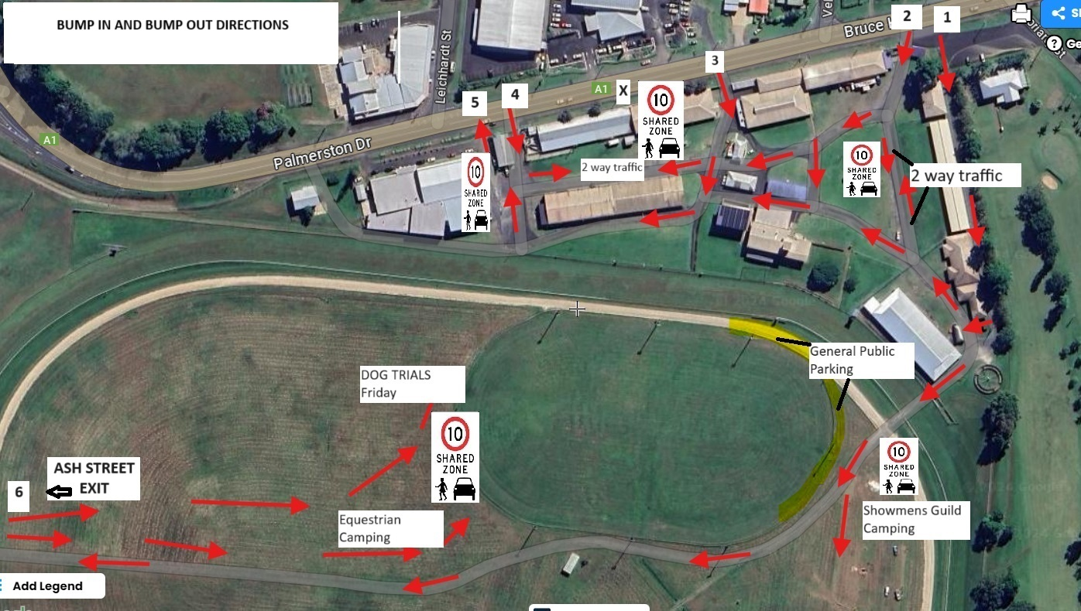

If your application for a stall is successful, you will be sent a Tax Invoice, Ticket Vouchers will be available at the Show Office for pick up and you will be shown your site. If unsuccessful, your Deposit will be returned. Cost per metre of frontage covers the two days of the show.

- Payment options are Cheque, Money Order, Direct Deposit, or in Person as per Show Office Hours.
- All requirements for the display including tables, chairs, and any equipment must be provided by the stallholder.
- Blue tac can be used on the walls. The walls must be left in the same condition as when you arrived.
- Paid parking is available inside the showgrounds, otherwise you can park outside the showgrounds whilst the gates are locked.
- Security will be available from 6.00pm on Wednesday, 8th July 2026, round the clock, until Saturday 12.00 Noon. Security will lock the pavilions at 10.00pm both Thursday and Friday nights, with all displays remaining set up on Thursday night.
- Displays can be set up Wednesday of Show Week, from 9.00am until 7.00pm, after which the pavilion will be closed. Displays can also be set up from 7.00am Thursday (7.00am for Outside Trade Displays).
- All vehicles must be removed from the Show Grounds by 10 am on Thursday of the Show, Foot traffic only after 10.00am as gates will be locked after this time. Due to the many trucks in the Show Ground during Show week, it may be more appropriate to park outside and walk in items for the display.
- Stallholders can continue setting up their displays between 10.00am and 1.00 pm (opening time) of the Thursday. Stallholders must be present by 9.00am on Friday of Show. Gates will be locked Wednesday night and will be opened by security guards as required for your entry into the Showgrounds
- Ticket Vouchers are not required on the Wednesday to gain access to the Showgrounds. As security is not available until 6.00pm on Wednesday, stallholders are responsible for their stalls prior to this time.
- You are provided with four (4) Ticket Vouchers to gain entry. These Vouchers are one use only, but an individual can gain a pass out stamp after producing a Ticket Voucher. Therefore, there are four single entries to the Show Grounds.
- Stallholders must remain setup for both days of the Show until 10.00pm on the Friday night. The pavilions will reopen on Saturday at 7.00am, with roaming security present. Displays not removed at this time may be at risk of theft due to the inability of security to monitor every display. All displays must be removed by 12.00pm on Saturday morning.
- The Pavilion hours for the public are approx. 1.00pm to 10.00pm on the Thursday and 9.00am to 10.00 pm on the Friday. Stalls must stay open for the public, failure to do so without Show Society permission could lead to banning in following years

- Showmen’s Guild continues operation until approx. 10.00pm.

